Clarification of school work during the school closure period
Following governmental advice the school is closed to all pupils. Key information will be passed to students through email and Microsoft Teams

We want to clarify how this work can be accessed. This can be done using a laptop or a smart phone/tablet
School Email
- Staff have been regularly emailing questions and links to students. Students who cannot access their school email address must follow the information here:
  - Click on https://www.office.com/?ref=login
  - Click on Sign In
  - Enter your school email address. If you have forgotten your email address it is as follows (Using K Hodgson as the example – you need to use your initial and your surname)
    - Year 7: 19khodgson@cma.bfet.uk
    - Year 8: 18khodgson@cma.bfet.uk
    - Year 9: 17khodgson@cma.bfet.uk
    - Year 10: 16khodgson@cma.bfet.uk
    - Year 11: 15khodgson@cma.bfet.uk
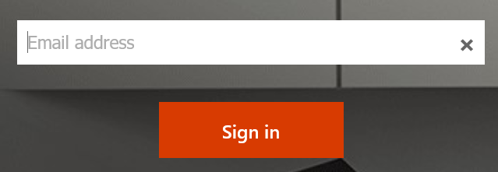
  - Your password is whatever password you usually use to log in to school computers
  - Your school email account can be found by clicking on Outlook
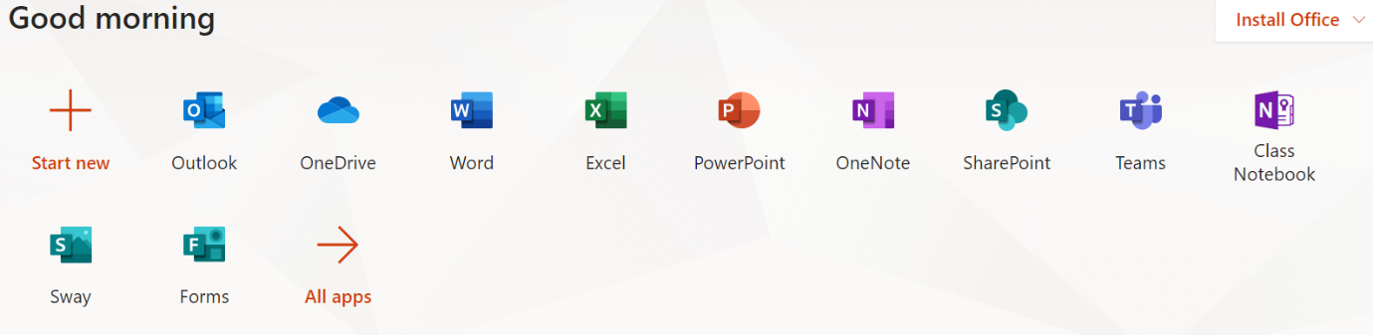

Microsoft Teams
- Staff have set up work groups using Microsoft Teams. Guidance to access teams is as follows
  - Log in to school email account using Office 365 as above.
  - Click on the Teams icon

  - All Teams that students have been invited to will appear here and students can access work, complete tests and message their teachers. For example, the Year 8 English Team is shown
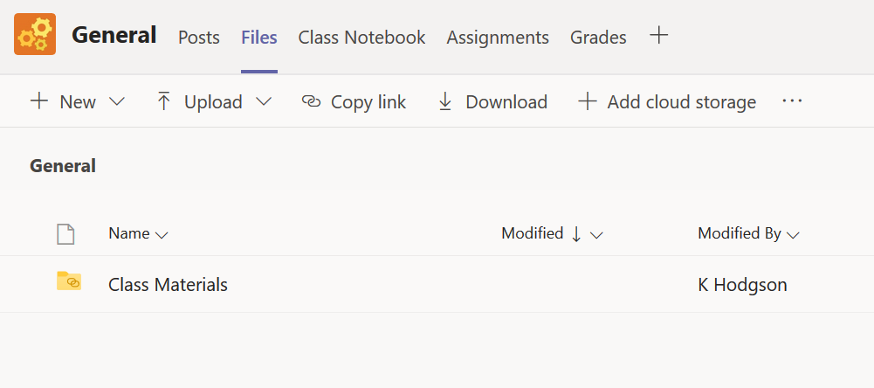
Teams on a Laptop/PC
We recommend you download the full version. When you log on to Team it can be found in the bottom left corner
Teams on a phone/tablet
We recommend you download the Teams app which is available from Google Play store or the Apple store. Here is the Google Play version
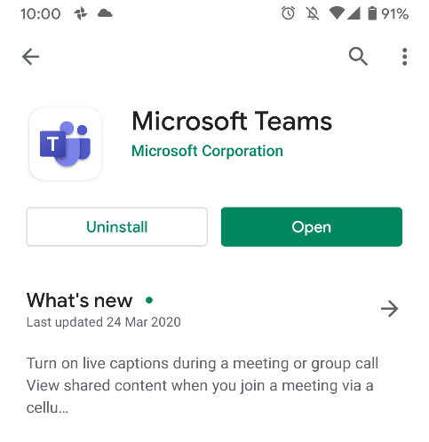

What work should students expect to do?
Year 7, 8 and 9
Students should use their knowledge organisers to recap important knowledge.
Students will have paper versions of these organisers for terms 1 and 2. They can also be download ed from the school website here: http://cedarmount.manchester.sch.uk/life-at-school/curriculum/
Knowledge organisers for term 3 will be added.
Guidance
- Knowledge organisers cover the factual information that pupils need to memories. The best use of time will be memorising this information so it can be recalled rapidly.
- The best methods to do this are:
  - Look, cover, write and check the key words and knowledge lists
  - Ask a family or friend member to test you on the knowledge
  - Create a mind map to remember the information in each section
  - Write down on a blank piece of paper as much as you can remember from the organiser
The school will test student knowledge on this information through school email and through Microsoft Teams

Years 10 and 11
Students in Year 10 should access Teams in the same way. Here is an example of work being set for students in Year 10:
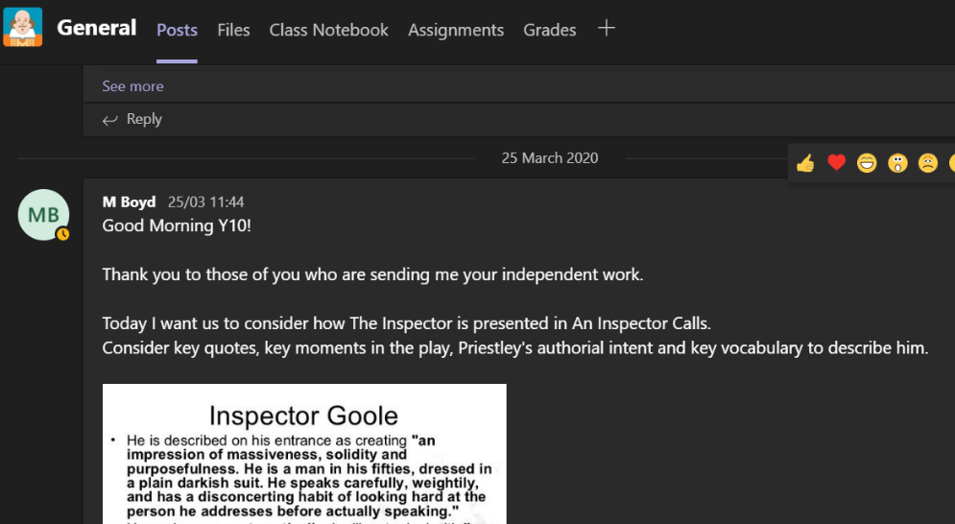
Students in Year 11 should work through their past papers and the additional work set over email/teams

Students will be set a minimum of one hour independent work per subject per week (on average 2 hours per day)

Mr Kal G Hodgson
Principal
Cedar Mount Academy
-------------------------------
Currently reading: Rebel Rebel by Chris O’Leary

