Parental Guide
(Browser)

Year 10 Parent evening
Thursday 4th February 15.30-18.30

You will receive notifications from us to inform you of the date and time the system will be live and open.
DESKTOP VERSION
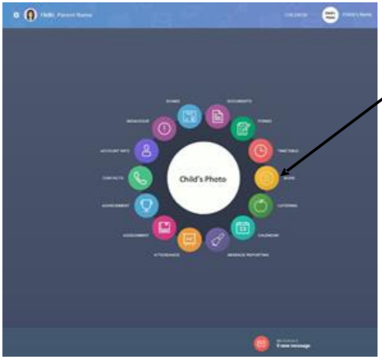

From the home screen, click ‘more’, then click the Parents’ Evening icon (displayed below)

The Parents’ Evening button will take you to the following screen

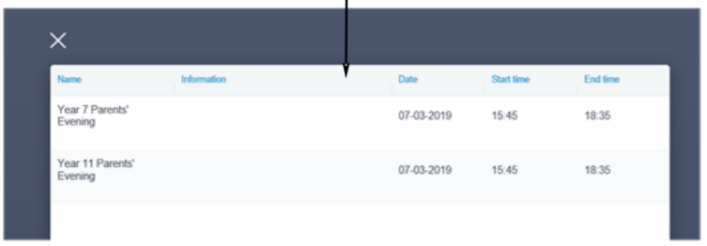
Select the appropriate option.
Please note that information will only show here if the booking system is currently live and open- it will close at 12pm on the 4th February.

Once you have selected the Parents’ Evening you will be attending, you will need to book time slots.
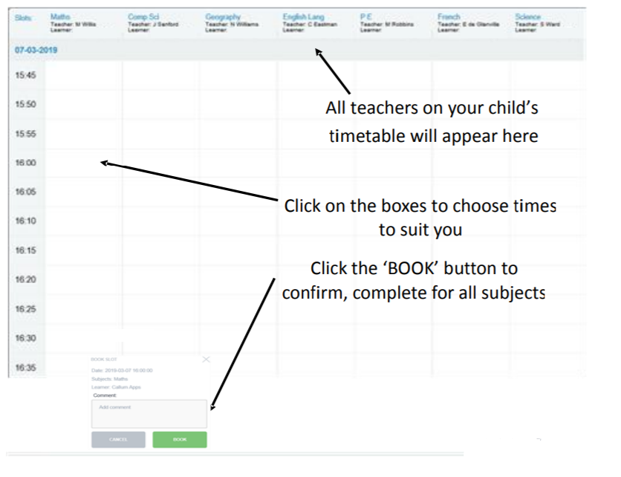
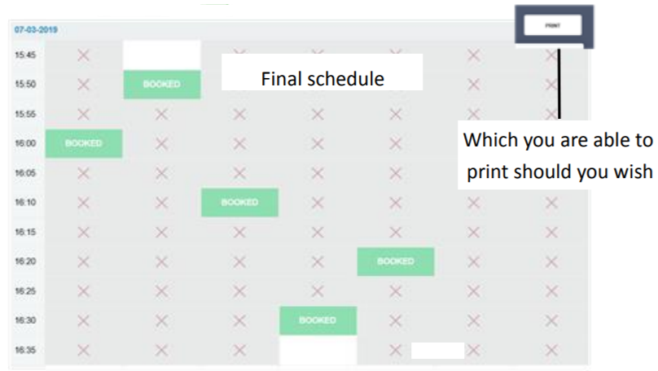
If you need to make amendments, follow the process again to book/unbook.

DESKTOP VERSION
Virtual Parents’ Evening
If choosing the desktop option for the virtual meeting please use Google chrome or Edge, using internet explorer will not work.
You must have a webcam and microphone for a desktop computer, most laptops have these built in, as do smart phones and tablets.

What to do on the day
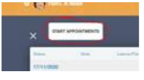
Once you have set up the event and all the bookings have been made, participants will see a start appointments button when clicking on the event.

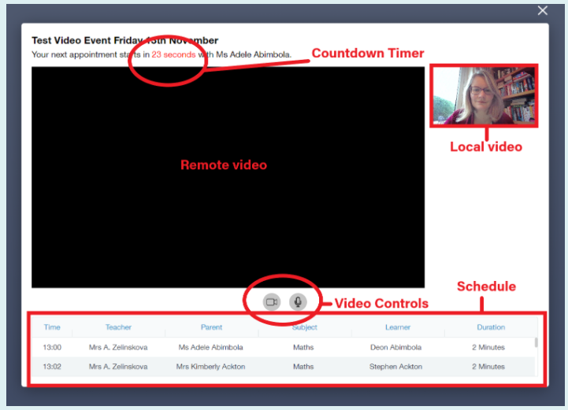
When clicking on the START APPOINTMENT button the meeting screen will appear. The remote video box will remain blank until it is time to connect, but you will be able to see your picture in the local video box. You can turn your video and sound on and off if needed with the controls.

The event will start automatically then auto navigate between the appointments without the need for user input. When the countdown gets to 30 seconds the time will turn red and as a warning at 15 seconds the border of the remote video box starts to flash red.
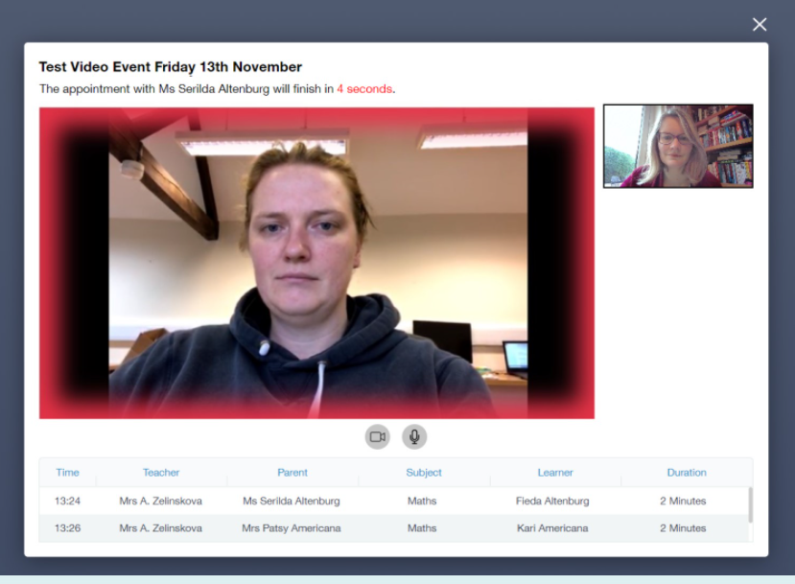

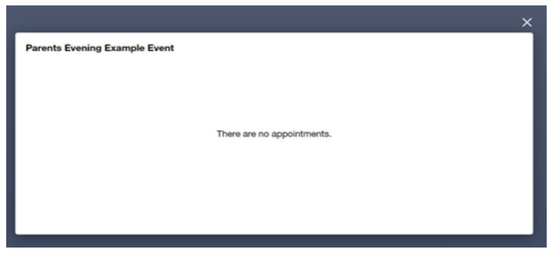
Once all of the appointments have taken place, the message “There are no appointments message” is displayed and the window can be closed.

