Cedar Mount Academy
Feedback, Assessment and Reporting Policy
2020
Contents
1 Aim 2
2 Rationale 2
2.1 General principles 2
2.2 Summative Assessment 2
2.3 Marking 6
2.4 Reflection and Improvement Time [RI Time] 7
2.5 The 5 Rs of Feedback 7
2.6 Feedback for SPaG 8
2.7 Feedback for calculations 8
2.8 Progress against curriculum objectives 8
3 Academy expectations 9
3.1 Expectations of the teacher 9
3.2 Expectations of the Head of Department 9
4 Reporting to parents 9
4.1 Agreed criteria 9
4.2 Years 7 to 9 (Key Stage Three) 10
4.3 Year 10 (Key Stage Four) 10
4.4 Year 11 (Key Stage Four) 11
5 References 13

Aim
Feedback and assessment is central to the quality of education offered at Cedar Mount Academy. This policy is designed to ensure that the quality of feedback given to students is of appropriately high quality to consistently impact on their learning. This is done to improve students’ knowledge and understanding and their ability to apply learning in different contexts. It is also designed to ensure any assessment is done with the focus on gathering data that will be used appropriately.

Rationale

General principles
Excellent teaching has high quality assessment at its heart. This policy understands that there is a difference between summative assessment and formative assessment. Summative assessment is designed for the recording of the overall achievement of a student in a systematic way whereas formative assessment is used so that the positive achievements of a student may be recognised and discussed, and the appropriate next steps may be planned. Formative assessment should lead to the most useful forms of feedback.
There is a plethora of academic research that points to the positive impact high quality feedback has on the progress and learning of students. “Feedback used in educational contexts is generally regarded as crucial to improving knowledge and skill acquisition… [and that in] addition to its influence on achievement, feedback is also depicted as a significant factor in motivating learning” (Shute 2008) and feedback “is among the most critical influences on student learning. A major aim of the educative process is to assist in identifying...gaps and to provide remediation in the form of alternative or other steps” (Hattie 2007).
Feedback from the teacher (or self/peer) should lead to thinking by the student. Without this, feedback is pointless. As Dylan Wiliam writes on his blog, “teachers should not give feedback to their students unless they plan time for students to respond—to build on the feedback, put it into practice, or reflect on how it can improve their work. Put simply, if it’s worth your spending time generating feedback, it’s worth taking instructional time to ensure that students respond.”

Summative Assessment
Summative assessments are design to give a summary of knowledge within a subject discipline. They are designed for the recording of the overall achievement of a student in a systematic way. We note that summative assessment is used to “describe learning achieved at a certain time for the purposes of reporting to parents, other teachers, the pupils themselves and, in summary form, to other interested parties such as school governors or school boards. It has an important role in the overall educational progress of pupils but not in day-to-day teaching” of students (Harlen 1997). “Test scores usually do not provide a direct and complete measure of educational achievement. Rather they are incomplete measures, proxies for the more comprehensive measures that we would ideally use but that are generally unavailable to us.” (Koretz 2008)
Summative assessments should be reliable and valid.

Reliability
Reliable scores show little inconsistency from one measurement to the next. For an assessment to be reliable it should provide consistent results across time. A student taking an assessment one day and again another day should get the same score if the test is reliable. A test can be made more reliable by being made longer, or even over several days. Multiple choice tests have a greater degree of reliability as do tests where there is less freedom of choice for students in the questions that answer.

Validity
The judgements made from a test need to be valid. A judgement about a student’s ability in a topic domain is valid if the assessment adequately samples from that domain. Judgements can be made more valid if a test is designed to cover exactly what is required to be tested at that point in the curriculum. Assessment must try to avoid construct underrepresentation and construct-irrelevance variance.
Construct underrepresentation is when an assessment does not sufficiently cover the concepts being judged.
Construct-irrelevance variance is when an assessment tests more concepts that those being judged.

Assessment timeline
Baseline | At the start of each academic year, A MidYis or Yellis assessment test to gather data about the baseline position of students and to suggest an assessment banding:  Band 1: A student in the upper 25% of attainers within that subject in the year group (these students typically go on to achieve grades 5 to 9 at GCSE)  Band 2: A student in the middle 50% of attainers within that subject in the year group (these students typically go on to achieve grades 2 to 6 at GCSE)  Band 3: A student in the lower 25% of attainers within that subject in the year group (these students typically go on to achieve grades 1 to 4 at GCSE
mid-year assessments | At an approximate half-way point in the year, and by the end of January at the latest, Years 7 to 10 will be formally assessed under exam conditions. These tests can only test a sample of content that has been taught and should be designed to ensure students have the most equitable opportunity to demonstrate the learning they have done over their time in school.
End of year assessments | At the end of the academic year, Year 7 to 9 will be formally assessed under exam conditions and where possible in a formal setting
Mock Examinations | Students on GCSE and BTEC courses will sit mock examinations designed to judge progress at that point in the course. These examinations will be sat in full formal condition, in the hall, utilising access arrangements as accurately as possible They will take place near the end of Year 10 and in the second term of year 11.

Departmental assessment
Throughout the year, departments may choose to set other assessments as a measure of progress against the curriculum. Whilst these assessments might be marked and graded, these grades and marks will not be reported home to parents on reports. Departments can choose to share these marks with students by whatever means they feel appropriate.

Moderation
“Moderation as judgement practice is central. It involves opportunities for teachers when they use their own judgements of assessment data to integrate these judgements with those of other teachers and in so doing share interpretations of criteria and standards” (Wyatt-Smith 2010)
All summative assessment should be moderated within the department to ensure teachers have an understanding of standards that underpin their judgement formation of student work. This moderation should include the following
- An agreed mark scheme or rubric to be followed by all markers
- An opportunity prior to marking to discuss the mark scheme or rubric
- Where possible, a distribution of assessment marking across different teachers from different classes
- A planned moderation meeting for teachers to discuss different ways of arriving at judgements for particular questions or responses

Formative Assessment (Responsive teaching)
High quality assessment in lessons can have the greatest impact on learning – if done correctly it allows students to learn well over time. In the most effective lessons teachers plan objectives and key knowledge, then plan assessment to test this knowledge and finally the activities to teach. They use responsive teaching to offer feedback that helps pupils improve. Responsive teaching leads to an adjustment in relevant knowledge as a result of the response evaluation (Bangert-Drowns 1991) as seen in their five-stage model:

Figure 1: Five-stage model of feedback
- The current state of the learner. This is characterized by the interest, understanding, and prior relevant knowledge.
- Search and retrieval strategies. Cognitive mechanisms activated by a question. Information is easier to locate in memory because of more pathways providing access to the information.
- The learner makes a response to the question and feels some degree of certainty about the response.
- The learner evaluates the response in light of the feedback. If correct, the learning may be strengthened or unaltered. If feedback indicated the incorrectness of the response, the learner may seek to understand the incongruity. The quality of the feedback is key to this evaluation.
- Adjustments are made to relevant knowledge. These adjusted states, with subsequent experiences, determine the next “current” state.

Verbal feedback
Should take place throughout most lessons as staff engage systematically with students, correcting errors and asking further questions. Verbal feedback should be positive and task-specific (“do this…” rather than “don’t do this…”) and should ensure that the responsibility to improve the work remains with the pupil. Verbal feedback should be brief and if not, then further instruction is needed, and the teacher should assess whether the concept needs to be retaught.

Questioning
When questioning, it is vital that a range of students are given the opportunity to respond. One standard approach to this is pose, pause, pounce, bounce: Pose a question. Pause to let pupils think. Pounce on a targeted student to answer. Bounce the evaluation or that question around the class – who agrees, who can clarify, who can explain or even simply repeat?
There are a range of questioning approaches, and these approaches can be used in combination.
Targeted questioning: By planning questions in advance teaching staff can ensure a mix of questions that allow students to demonstrate their knowledge or demonstrate their thinking. This type of assessment may only assess one or two students at a time and so should be distributed across the class wherever possible. Questioning should lead to corrective verbal feedback. See Appendix D for suggestions and advice.
Hinge-point questions: By using a well-designed multiple-choice questions teachers can quickly and precisely assess knowledge and understanding. This informs staff whether it is appropriate to move on to the next phase of learning or if more consolidation and practice is needed. The multiple choice can be via A, B, C, D or students can hold up a number of fingers to indicate their answer. Ideally, incorrect answers are designed to highlight typical misconceptions. See Appendix C for advice on constructing multiple-choice questions.
Think-pair-share: When asking a question give students 30 seconds to think in silence. Then give them 1 minute to discuss the answer with a partner, and even an additional minute for pair to share with other pairs. Now that everyone has rehearsed their answer anyone can be chosen to speak, and because they have mutually developed an answer, they share the “burden” if they are wrong. Approaches are detailed in Appendix F .
Mini-whiteboards: Check whole class understanding through a “show me” approach where students can show their answers after a short count down. By seeing all students’ answers teachers can spot students who need additional support. Ensure students can’t easily copy from other whiteboards. This approach can lead to good whole class feedback.

Testing
Tests are a simple and effective way to encourage students to retrieve knowledge and test understanding.
Low or no stakes testing: By testing previously taught knowledge at the start of lesson, through a quick set of five questions, responses can be self-marked, there are no negative consequences for poor performance and on some occasions the teacher will not even find out the score. Such tests should not be assigned a percentage or grade. The focus should be on what the test tells the pupil and teacher about the next steps required for the pupils to improve. You can use these tests to interleave other prior learning so that students are not being assessed on one topic at a time.
Exit tickets: Giving students a task to complete at the end of the lesson allows teacher to diagnose the success of your teaching and helps plan the next lesson. This can also lead to individual feedback by analysing student responses.
Online assessment: Platforms such as Teams and Forms allows for quick, simple and where appropriate, automatically marked assignments.

Homework
Homework is a key opportunity for students to revise, learn and apply knowledge. There is an expectation that teachers set appropriate and regular homework according to the agreed departmental timetable. Appropriate homework supports the learning of students and can include memorising material from the knowledge organiser and reading. A learning or recall homework should be set once per cycle.
Following homework students must receive feedback through at least one of the agreed methods.
Whole-class feedback: Teachers should look through homework, make brief notes and give ‘whole class feedback’ the following lesson. To do this, a teacher would make notes about common errors and add them to the schemes of learning in order to address these potential pitfalls when the topic is delivered in the future. See Appendix E for a model approach to Whole class feedback.
Individual written feedback: When teachers give individual written feedback on homework, it should not come in the form of a grade, but comment on what is specifically good about the work and give one or two suggestions for improvement that can be actioned by the students (see “2.5 The 5 Rs of Feedback”). These follow-up tasks should be more work for the student than for the teacher and teachers should encourage pupils to look back on previous feedback before completing future tasks.
Automatic feedback: Where online assessment is used for homework, the most efficient form of feedback is the use of Microsoft Forms to give immediate feedback.
Peer and self-assessment: When appropriate (see below) homework can be marked by students or their peers.

Peer and self-assessment
Self-assessment and self-marking leads to students being able to recognise and learn from their mistakes if a clear rubric or answer is given. Peer-assessment allows for students to learn from the ideas of others, but care must be taken to ensure there are clear descriptors of success criteria to ensure students give appropriate and valuable feedback.

Marking
Whist this is the most obvious form of feedback, it is not always the most efficient. Teachers must ensure they have a clear goal in mind when marking students work by ensuring it is not something that could be assessed in a different way. Marking work allows a teacher to give time to students’ own work and demonstrate that it is valued. Sometimes the most powerful feedback is done by reading students’ work and writing comments that support further development.
It is expected that individual departments set out their policy for assessment and feedback, incorporating marking, as Appendix A to this policy.
Department policies for marking must adhere to the 3 principles of effective marking set out in the DfE document ‘Eliminating unnecessary workload around marking’
- Meaningful: Marking varies by age group, subject, and what works best for the pupil and teacher in relation to any particular piece of work. Teachers are encouraged to adjust their approach as necessary and trusted to incorporate the outcomes into subsequent planning and teaching.
- Manageable: Marking practice is proportionate and considers the frequency and complexity of written feedback, as well as the cost and time-effectiveness of marking in relation to the overall workload of teachers.
- Motivating: Marking should help to motivate pupils to progress. This does not mean always writing in-depth comments or being universally positive: sometimes short, challenging comments or oral feedback are more effective. If the teacher is doing more work than their pupils, this can become a disincentive for pupils to accept challenges and take responsibility for improving their work.

Key principles of marking
Consistency is important, but that consistency should come from high expectations rather than a model that does not vary across departments. Inflexible timing and systems are not helpful.
- It should follow an opportunity for students to check their work prior to handing in
- It should be selective: a teacher does not need to mark everything
- It must be decided at department level – one size cannot fit all
- It must be done in such a way that students can act upon it (see “2.5 The 5 Rs of Feedback”)
- It should not be graded in any way
- It should include feedback for spelling, punctuation and grammar.

Reflection and Improvement Time [RI Time]
Any form of feedback should lead to action from the student. Time must be given to students to complete this action. This may be in the form of immediate correction, or in more formal reflection and improvement time. This RI time can take as long as the teacher feels is necessary, but the action should conform to one of The 5 Rs of Feedback that support learning.
Metacognitive tasks and self-regulated learning have been shown to be effective parts of RI time. The metacognition knowledge in the feedback process refers to what learners know about learning. This includes:
- The learner’s knowledge of their own cognitive abilities (e.g. “I have trouble remembering key dates in this period of history”).
- The learner’s knowledge of a particular task (e.g. “The politics in this period of history are complex”).
- The learner’s knowledge of the different strategies that are available to them and when they are appropriate to the task (e.g. “If I create a timeline first it will help me to understand this period of history”).
Self-regulation, meanwhile, refers to what learners do about learning. It describes how learners monitor and control their cognitive processes. For example, a learner might realise that a particular strategy is not yielding the results they expected so they decide to try a different strategy. Self-regulated learners are aware of their strengths and weaknesses, and can motivate themselves to engage in, and improve, their learning. Appendix B lists suggested Prompt questions for metacognition that the teacher can ask in the lesson or in the written feedback. At first, the teacher will need to prompt the students to reflect and self-regulate their work but over time the students will start to develop the skill themselves, making them more effective learners.

The 5 Rs of Feedback
For feedback to be effective it needs to focus less on what has gone before and more in terms of very specific actions that students should take in order to move forward.
Generic evaluative feedback such as “you need to improve the structure of your paragraphs” or “try to include more original ideas” are unhelpful. Therefore, teacher should focus on allocating tasks to students that address their learning needs. A student should be able to read or hear their teacher’s feedback and then do something very specific and concrete that will improve their learning.
This can be simplified through five approaches.
- Re-draft or re-do the work: go back and edit parts of it
- Rehearse or repeat: go back and practice again and again
- Revisit and respond: go back and practice by answering more similar questions
- Re-learn and re-test: go back and make sure you understand previous learning
- Research and record: go back and develop work using wider references

Feedback for SPaG
All staff should support the development of students’ written communication through high quality, well planned instruction, but opportunities to give students feedback to improve their spelling, punctuation and grammar must be taken as well. Some of this feedback will be verbal, some can be covered through whole-class feedback and some will occur during marking. Students should again be given time to action this feedback. Written marking for spelling, punctuation and grammar should use margin codes to simplify the process. Not all errors should be pointed out and teachers should be selective for different students’ errors, knowing when to leave them leave alone, when to nod gently towards them, and when to point them out.
Concern or error | Student action | Margin code
Spelling mistake | Re-learn the correct spelling. Cover and write out. Re-do this three times from memory. | Sp
Incorrect use of capital letter | Write out the correct word. Cover and write out. Re-do this three times from memory. | CL
A new paragraph is needed | Re-do the section adding a paragraph break for a new time, place, topic or person (TiP-ToP method) | //
A missed out a word | Re-do the sentence and ensure it makes sense | ^
A punctuation error | Re-do the sentence with the correct punctuation | P
Meaning is unclear | Re-do the sentence and ensure it makes sense | ?
Wrong word or tense is used | Write out the correct word. Cover and write out. Re-do this three times from memory. | !!

Feedback for calculations
Whenever appropriate, staff should also develop student numerical communication skills and accuracy. Feedback for numeracy should support the student in knowing how to improve or correct work that involves numeracy, calculations or logical thinking.
Concern or error | Student action | Margin code
Working should be shown | Re-do the question showing the working at the side of the answer | SW
A calculation error | Re-do the question checking the calculation carefully | CE
Wrong number | Re-do the calculation and write the correct number down | O

Progress against curriculum objectives
The curriculum is the progression model and departmental curriculum maps are designed to demonstrate the knowledge that students should demonstrate at key points throughout the year. It is for departments to decide what this progression looks like and what is expected of students who are meeting curriculum objectives. Students making expected progress are expected to stay in the same estimated band year on year.

Academy expectations

Expectations of the teacher
- To give feedback of the highest possible quality at all appropriate opportunities
- To explore and use a range of responsive teaching techniques
- To follow an agreed departmental policy for feedback and assessment
- To ensure summative assessments are marked in a timely way and data entered into SIMS by agreed deadlines
- To use academy literacy and vocabulary codes as appropriate when marking
- To refer to and use the “5 Rs of Feedback” when supporting students to improve their work
- To give students appropriate reflection and improvement time

Expectations of the Head of Department
- To ensure the department has an effective and appropriate, published departmental feedback and assessment policy attached as Appendix A in this policy, and which takes into consideration the different feedback strategies so as to assist staff in managing their workload
- To ensure all members of their department understand the policy and the range of responsive teaching techniques
- To monitor the quality and consistency of feedback across the department
- To ensure moderated consistency across all summative assessment marking and that all agreed summative assessment are as reliable as can be and that judgments made are valid
- To ensure the departmental assessment timeline is reflected in the curriculum maps
- To ensure all deadlines for summative assessment marking and data entry are met
- To monitor and support the marking workload of members of their department, ensuring that agreed assessment impacts positively on student learning

Reporting to parents

Agreed criteria
When reporting to parents, some common criteria will be used for all year groups. These criteria will allow the school to report on students’ attitude to homework, their organisation and their behaviour in lessons. In addition, attendance data will be reported.
Attendance
Student attendance will be reported on using the following scale
⇦⇦Below 94% | 94% | 95% | 96% | 97% | 98% | 99% | 100%
Inadequate | Requires improvement |  |  | Good |  | Excellent
Homework*
- Has handed all homework in on time and it shows consistently high levels of effort.
- Has mostly handed in homework in on time or the homework completed does not show suitable levels of effort.
- Regularly fails to hand homework in, or the effort made with the homework is unsatisfactory.
Organisation*
- Always brings the required equipment to lesson, this includes a pen, pencil, ruler, their planner and knowledge organiser and a reading book along with any specialist equipment e.g PE Kit.
- Sometimes forgets to bring the required equipment to lesson.
- Regularly fails to bring the required equipment to lesson.
Behaviour*
- The student is well behaved, consistently remains on task and focused in lessons and arrives at lessons on time and ready to learn.
- The student can sometimes be distracted in lessons, occasionally has poor behaviour and/or does not always arrive to lessons on time.
- The student consistently displays poor behaviour in lessons and/or poor punctuality to lessons.
*We would anticipate that that most of our students are achieving a 1 all categories. A 2 or 3 would indicate a cause for concern.
NB. If a student is awarded a 3, then the internal CONCERN column must also be completed.

Years 7 to 9 (Key Stage Three)
Years 7, 8 and 9 will have two data collection points. As well as collecting judgments on students’ attendance, behaviour in class, homework and organisation, the school will collect data on attainment and progress from prior data. This data should be completed in the appropriate marksheet in SIMS.

Interim and end of year reporting

Attainment
For subjects that have a mid-year or end of year examination, students will receive a percentage attainment score and a related attainment band. For non-examination subjects the school will report home an attainment band based on the work completed over the course of the year. It will be for subject teachers to determine the band for each student, generally following the percentages below, but allowing for flexibility from group to group.
Band 3 | Band 2 | Band 1
The exam result places the student in the lower 25% of attainers within that subject in the year group (these students typically go on to achieve grades 1 to 4 at GCSE) | The exam result places the student in the middle 50% of attainers within that subject in the year group (these students typically go on to achieve grades 2 to 6 at GCSE) | The exam result places the student in the upper 25% of attainers within that subject in the year group (these students typically go on to achieve grades 5 to 9 at GCSE)

Progress
Progress will be based on prior data taken from MidYis moderated by teacher expertise and judgement.
- Expected progress: The student’s attainment is within the expected banding for their known prior ability
- Below expected progress: The student is not within the expected banding for their known prior ability.

End of year report
In addition to judgments on students’ attendance, behaviour in class, homework, organisation, attainment and progress the end of year report will contain a written summary by the form tutor.

Year 10 (Key Stage Four)
Years 10 will have two data collection points. As well as collecting judgments on students’ attendance, behaviour in class, homework and organisation, the school will collect data on attainment and progress from prior data. This data should be completed in the appropriate marksheet in SIMS.

Interim and end of year reporting

Attainment
For subjects that have a mid-year or end of year examination, students will receive a percentage attainment score and a related attainment band. It will be for subject teachers to determine the band for each student, generally following the percentages below, but allowing for flexibility from group to group.
Band 3 | Band 2 | Band 1
The exam result places the student in the lower 25% of attainers within that subject in the year group (these students typically go on to achieve grades 1 to 4 at GCSE) | The exam result places the student in the middle 50% of attainers within that subject in the year group (these students typically go on to achieve grades 2 to 6 at GCSE) | The exam result places the student in the upper 25% of attainers within that subject in the year group (these students typically go on to achieve grades 5 to 9 at GCSE)

Progress
Progress will be based on prior data taken from Yellis moderated by teacher expertise and judgement.
- Expected progress: The student’s attainment is within the expected banding for their known prior ability
- Below expected progress: The student is not within the expected banding for their known prior ability.

End of year report
In addition to judgments on students’ attendance, behaviour in class, homework, organisation and progress the end of year report will contain a mock examination grade and a written summary by the form tutor.

Attainment
For all examination subjects, students will receive a mock examination grade and a related attainment band.
Band 3 | Band 2 | Band 1
The mock exam result places the student in the lower 25% of attainers within that subject in the year group (these students typically go on to achieve grades 1 to 4 at GCSE) | The mock exam result places the student in the middle 50% of attainers within that subject in the year group (these students typically go on to achieve grades 2 to 6 at GCSE) | The mock exam result places the student in the upper 25% of attainers within that subject in the year group (these students typically go on to achieve grades 5 to 9 at GCSE)

Year 11 (Key Stage Four)
Years 11 will have two data collection points. As well as collecting judgments on students’ attendance, behaviour in class, homework and organisation, the school will collect data on attainment and progress from prior data. This data should be completed in the appropriate marksheet in SIMS.

Interim reporting
In addition to judgments on students’ behaviour in class, homework, organisation, and progress the interim report will contain a written summary by the form tutor.

Attainment
For subjects that have a mid-year or end of year examination, students will receive a percentage attainment score and a related attainment band. For non-examination subjects the school will report home an attainment band based on the work completed over the course of the year. It will be for subject teachers to determine the band for each student, generally following the percentages below, but allowing for flexibility from group to group.
Band 3 | Band 2 | Band 1
The exam result places the student in the lower 25% of attainers within that subject in the year group (these students typically go on to achieve grades 1 to 4 at GCSE) | The exam result places the student in the middle 50% of attainers within that subject in the year group (these students typically go on to achieve grades 2 to 6 at GCSE) | The exam result places the student in the upper 25% of attainers within that subject in the year group (these students typically go on to achieve grades 5 to 9 at GCSE)

Progress
Progress will be based on prior data taken from Yellis moderated by teacher expertise and judgement.
- Expected progress: The student’s attainment is within the expected banding for their known prior ability
- Below expected progress: The student is not within the expected banding for their known prior ability.

Mock examination report
In addition to judgments on students’ behaviour in class, homework, organisation, and progress the end of year report will contain a written summary by the form tutor and a report home on mock examination attainment following the mock exams.

Attainment
For all examination subjects, students will receive a mock examination grade and related attainment band as well as a predicted grade.
Band 3 | Band 2 | Band 1
The mock exam result places the student in the lower 25% of attainers within that subject in the year group (these students typically go on to achieve grades 1 to 4 at GCSE) | The mock exam result places the student in the middle 50% of attainers within that subject in the year group (these students typically go on to achieve grades 2 to 6 at GCSE) | The mock exam result places the student in the upper 25% of attainers within that subject in the year group (these students typically go on to achieve grades 5 to 9 at GCSE)
- Predicted grade: Students will also receive a predicted grade based on performance in the mock examination and more general subject performance.

References
Bangert-Drowns, Robert L and Kulik, Chen-Lin C and Kulik, James A and Morgan, MaryTeresa. 1991. “The instructional effect of feedback in test-like events.” Review of educational research 61 (2): 213-238.
Harlen, Wynne and James, Mary. 1997. “Assessment and learning: differences and relationships between formative and summative assessment.” Assessment in Education: Principles, Policy & Practice 4 (3): 365-379.
Hattie, John and Timperley, Hele. 2007. “The power of feedback.” Review of educational research 77 (1): 81-112.
Koretz, Daniel M. 2008. Measuring up. Harvard University Press.
Shute, V.J. 2008. “Focus on formative feedback.” Review of educational research 78 (1): 153-189.
Wyatt-Smith, Claire and Klenowski, Val and Gunn, Stephanie. 2010. “The centrality of teachers’ judgement practice in assessment: A study of standards in moderation.” Assessment in Education: Principles, policy & practice 59-75.

Departmental assessment policy

Minimum Expectations for assessment
Expectations for assessment reflect the broader aims and content of this policy.
[Departments should set out departmental expectation for assessment, which should be reflected in the curriculum scheme of learning. It should clarify common assessments, low stakes tests and progress tasks as well as the mid-year, mock and end of year examinations. Any discussion of marking should set out how that marking is meaningful, manageable and motivating. See section 2.3.]

Homework expectations
[Departments should set out expectations around agreed common homework and related feedback, including the use of the knowledge organisers, Teams, learning and reading homework. See section 2.2.10.]

Moderation
Departmental leaders will be asked to clarify moderation approaches in line management and leadership team meetings.
[Department leaders should set out how the department will agree consistency in assessment. See section 2.2.5 for advice.]

Recording of assessment
[Note that the only data to be submitted for whole school analysis will be the mid-year and end of year assessment and reporting data as noted in section 4. Departments should set out which other assessment data should be recorded by teachers and how it will be used. For example, a data tracker of summative assessments.]

Quality assurance
Senior leaders will review curriculum coverage and evidence of learning through two curriculum conversations per subject per year. These conversations will involve a discussion with teaching staff and with a sample of students to review and assure learning that has taken place across the academic year.
[Departmental leaders should set out how and when quality assurance processes will take place to ensure staff are meeting agreed expectation as set out in this policy.]

Prompt questions for metacognition
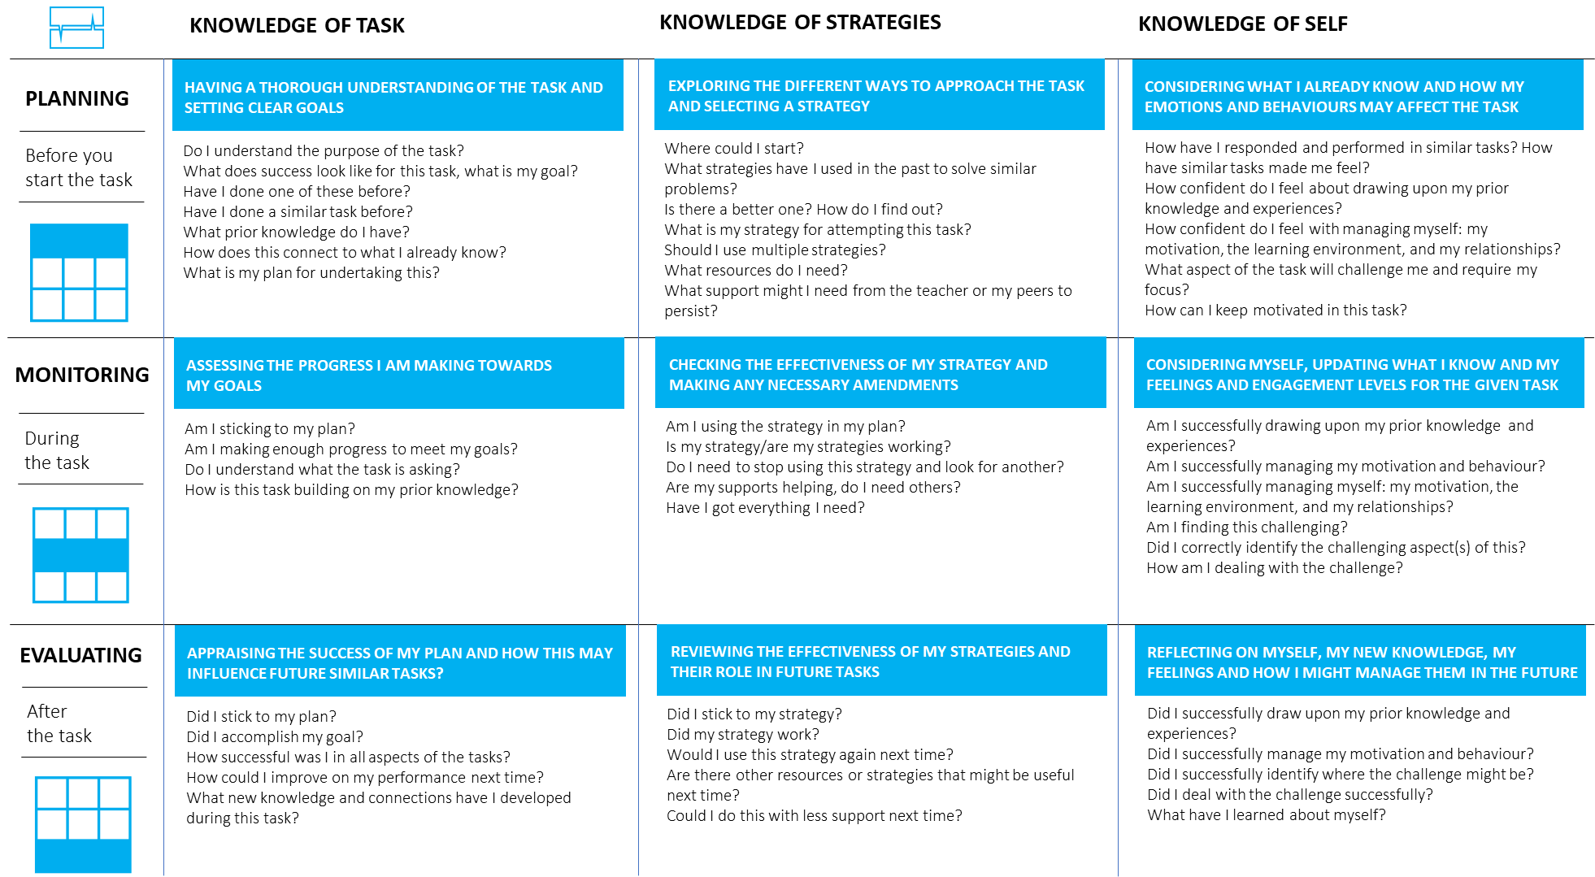

Advice for multiple choice questions

Framework for multiple choice questions (MCQ)
A multiple-choice question consists of a problem, known as the stem, and a list of suggested solutions, known as alternatives. The alternatives consist of one correct or best alternative, which is the answer, and incorrect or inferior alternatives, known as distractors. | 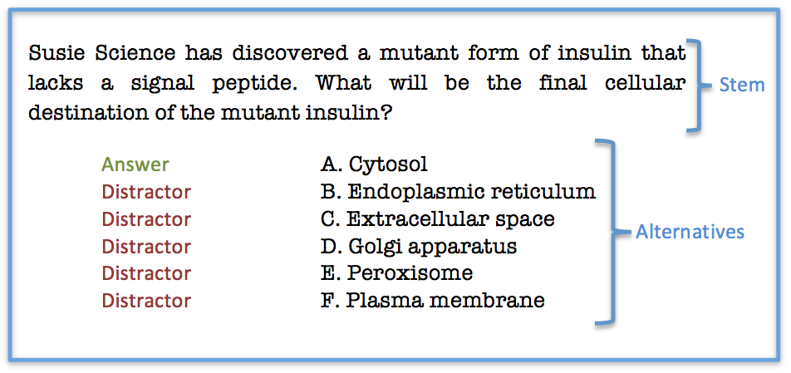

Effective stems
Advice | Example | Non-example
Present a definite problem and are meaningful on their own | What property do all prime numbers have? | Which of the following statements is true?
Do not contain material irrelevant to the concept being tested | What is Newton’s 2nd law of motion? | Newton related many laws written up in his book Pricipia Mathematica in 1687. What is his 2nd law of motion
Avoid negative stems | Which of Henry VIIT’s wives survived after his? | Which of the following is not true about Henry VIII?
Where possible use full questions | In addition to the nucleus, which organelles contain DNA? | In addition to the nucleus _________ are organelles which contain DNA

Effective alternatives
Advice | Example | Non-example
Alternatives should be plausible | A: Boris Johnson  B: Tony Blair  C: John Major | A: Boris Johnson  B: Rio Ferdinand  C: Lady Gaga
Alternatives should be stated clearly and concisely to avoid testing reading if that is not the aim. | What is a hypothesis?  A: A statement to be supported or not | What is a hypothesis?  A: A conception or proposition formed by speculation or deduction or abstraction and generalisation from facts
Alternatives should be mutually exclusive. | At what age can you drive?  A: 15  B: 17  C: 21  (You can drive at ages 17 and 21) | What is the minimum age at which is it legal to drive?  A: 15  B: 17  C: 21

Additional guidelines
Avoid complex multiple-choice items such as those given in the example, or options such as “none of the above” or “all of the above” as where students can use partial knowledge to arrive at a correct answer

Advice for targeted questioning

Planning for questioning
Teachers should ensure they know their students well in order to ask targeted questions to probe and develop individual student knowledge. Whilst teachers often consider different hierarchies of questions (lower and higher order) using the term hierarchy implies that questioning is superior to another when in fact all question types are vital when targeting questions to individuals.

Four classes of communication
There are fours approaches to classroom communication. Teachers should consider which is the most effective when targeting individual students are teaching whole class:

Interactive/dialogic
Teacher and student consider a range of ideas. An open-ended discussion where the teacher responds authentically to student responses and engages in a real dialogue with students and class.

Non-interactive/dialogic
The teacher reviews different points of view ultimately funnelling student response to a specific point of view. The teacher uses question and answer to review ideas and lead the students to a specific position.

Interactive/authoritative
Here the teacher focuses on one specific point of view from the start and leads students through a question and answer routine with the aim of establishing and consolidating that point of view or testing knowledge.

Non-interactive/authoritative
The teacher presents a specific point of view and may use targeted questions to ensure student know that point of view and the subsequent related knowledge.

Question matrix
The matrix can be used to create different questions stems to support the targeting of questions. There is no hierarchy to these stems which should be used to capture different information from different students.
 | Is | Did/does | Can | Would/Should | Will | Might/Could
What
Where/when
Which
Who
Why
How
Examples:
- “What is the name of the main character of A Christmas Carol”
- “How might Scrooge act in the years following the end of the book?”

Student-led questioning
A different approach to targeted questions is student led questions. Giving students the opportunity to generate their own questions gives them the advantage of being aware of their own learning process, resulting in improved learning outcomes. Students usually need a certain amount of knowledge about a topic before they can generate worthwhile questions so teachers should plan carefully to ensure teaching time is not wasted on extraneous concepts but tightly focused on the learning at hand. The matrix can be used to help students generate their own questions.

Whole class feedback
The following grid is an effective way to review a whole set of books and give whole class feedback. The teacher should complete this document rather than writing individual comments in students books and this guide used to form the basis of student intervention.

Crib sheet
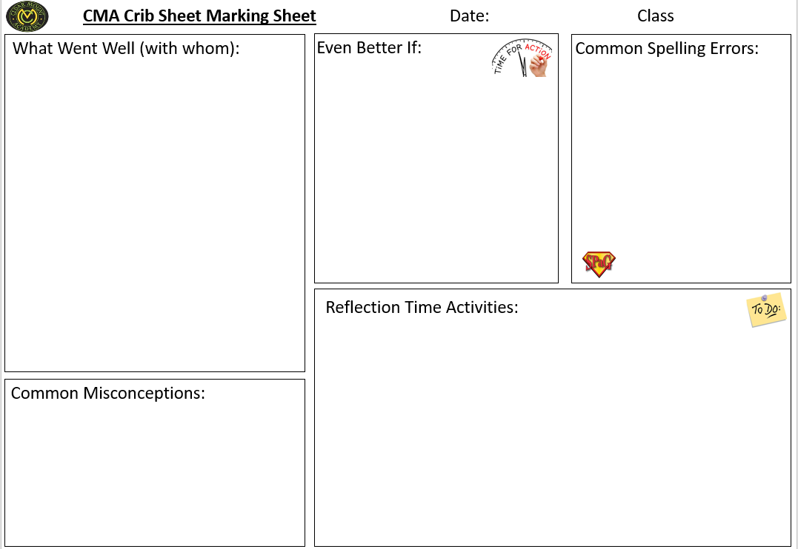

Strip Marking
An alternate approach involves pre-prepared common misconceptions/questions that can be glued in down the side of the students’ book and students’ action it next to it.
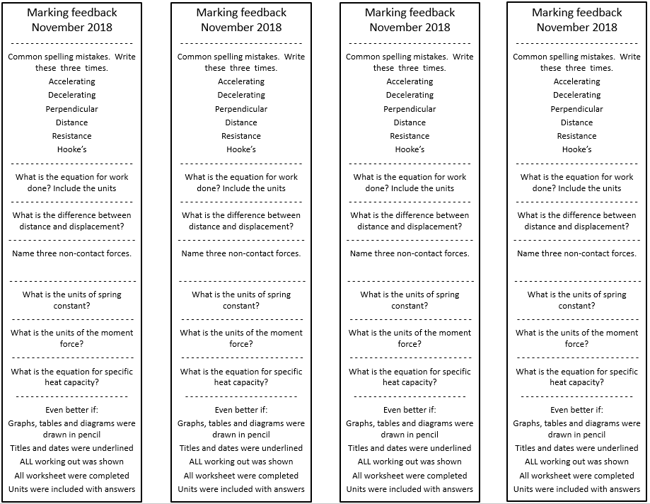

Think pair share
The following diagram sets out a range of approaches to using think pari share for responsive teaching.
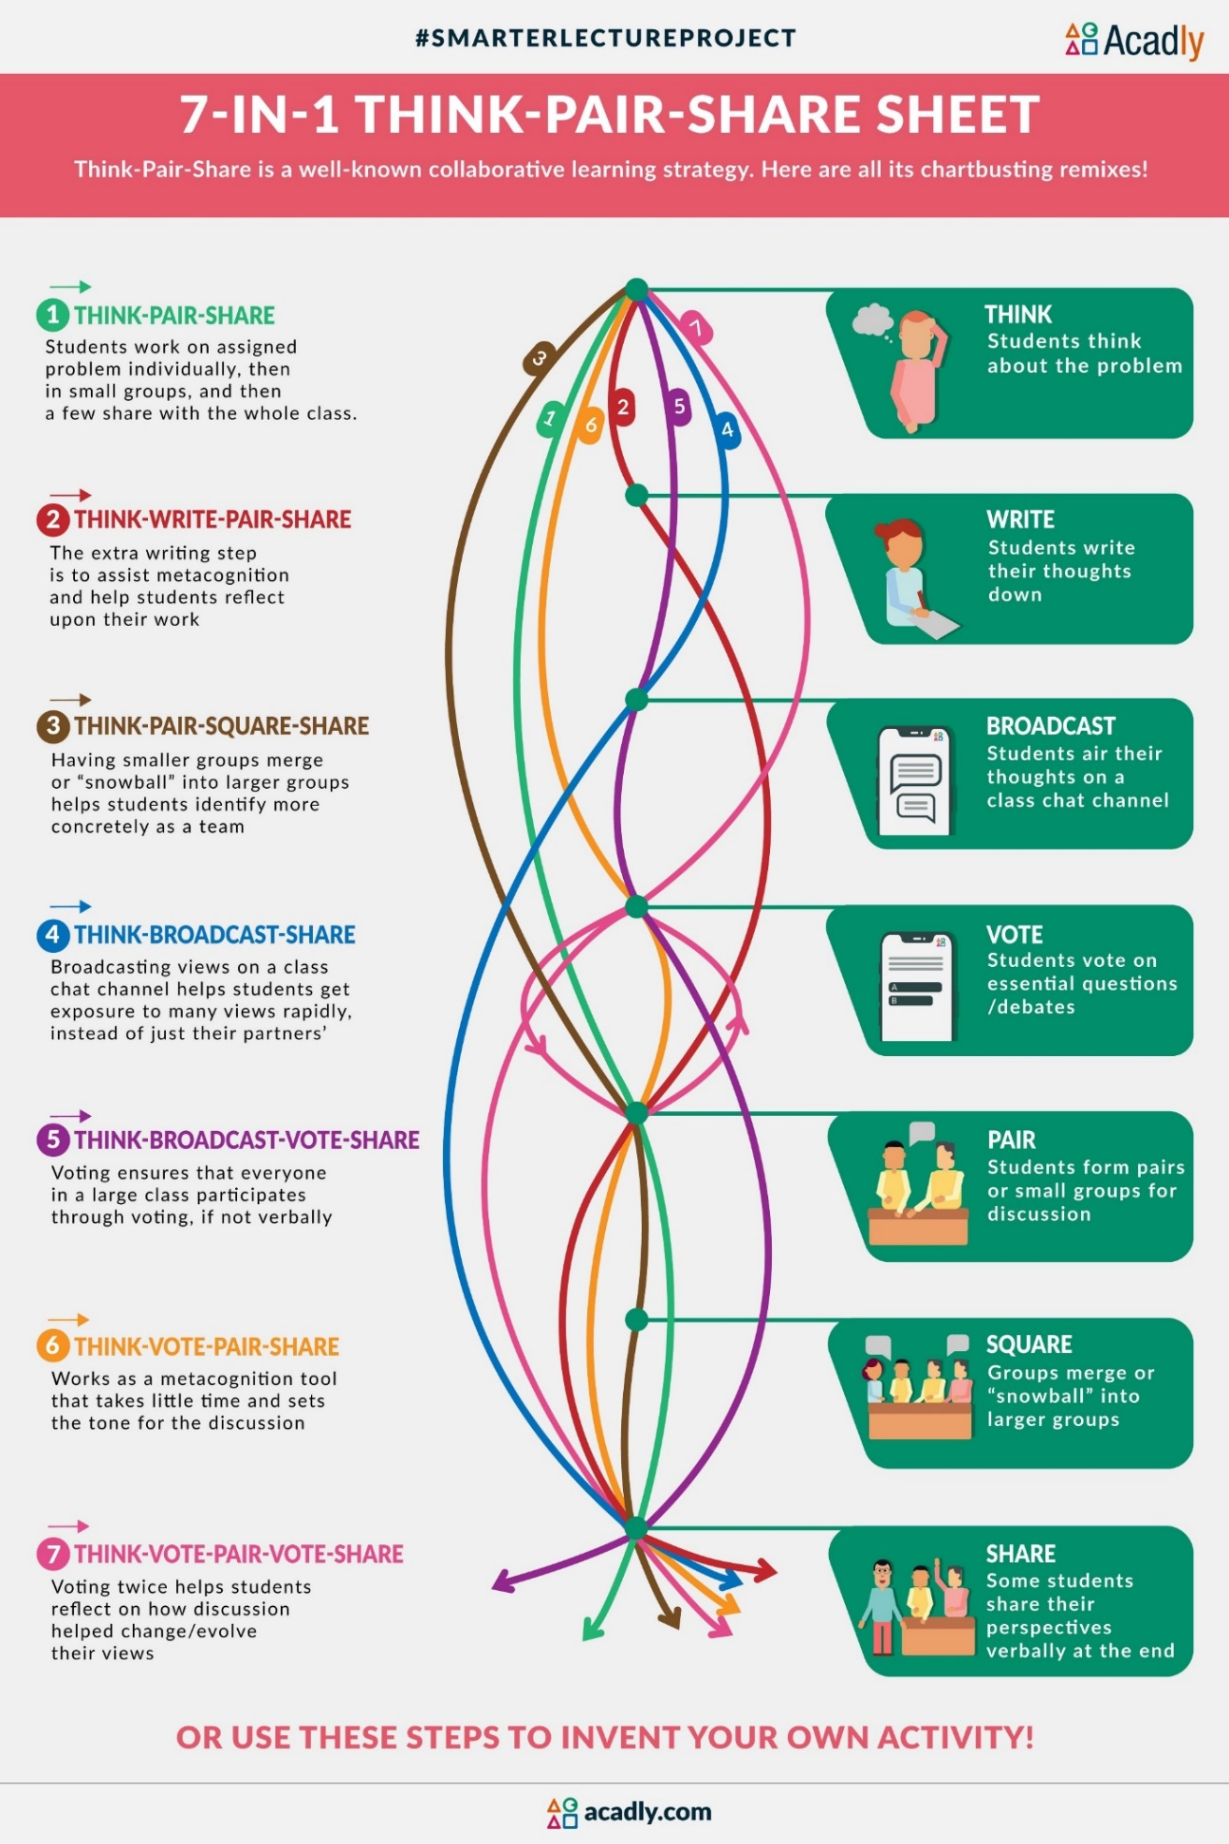

Workload considerations
Taken from the EEF report A marked improvement there workload considerations can support departmental heads in planning an effective subject specific assessment policy.

Grading
Decisions about whether to grade work do have workload implications, particularly if schools decide to moderate or standardise grading within a department. Given the evidence summarised above this does appear to be an area where workload could be reduced.

Corrections
It is likely to be more time consuming to pose questions or provide hints to correct errors. However, some of this time may be offset by the time saved not correcting mistakes. Using coded feedback is likely to save time.

Thoroughness
While simple ‘acknowledgement marking’, or the provision of a short comment such as ‘good effort’ may have been commonplace in the past, it is likely that these forms of marking could be reduced without any negative effect on student progress. A simple mantra might be that teachers should consider marking less, but marking better. Clearly moving to a form of selective marking could substantially reduce marking workloads.

Pupil responses
Setting aside class time for pupils to consider and respond to marking should not increase marking workloads unless teachers are required to mark responses. Unless some time is set aside for pupils to consider written comments it is unlikely that teachers will be maximising the impact of the marking that they have completed out of class time.

Creating a dialogue
Dialogic and triple impact marking clearly have the potential to generate large quantities of additional workload. While there does appear to be some promise underpinning the idea of creating a dialogue, further evaluation is necessary both to test this promise and to determine whether any resultant benefits are large enough to justify the time required.

Targets
Writing targets that are well-matched to each student’s needs could certainly make marking more time-consuming. One strategy that may reduce the time taken to use targets would be to use codes or printed targets on labels. Research suggests that there is no difference between the effectiveness of coded or uncoded feedback, providing that pupils understand what the codes mean. However, the use of generic targets may make it harder to provide precise feedback.

Frequency and speed
Decisions about the frequency and speed of marking have the greatest impact on time of any aspect of marking considered in this review. The evidence gap in this area means that it is not possible to identify clear time-savings in this area, or provide definitive guidance on how often or how quickly to mark.

See https://cft.vanderbilt.edu/guides-sub-pages/writing-good-multiple-choice-test-questions/
https://educationendowmentfoundation.org.uk/evidence-summaries/evidence-reviews/written-marking/

