The Duke of Edinburgh award at Cedar Mount Academy
ABOUT THE AWARD
Duke of Edinburgh is a life-changing experience. A fun time with friends. An opportunity to discover new interests and talents. A tool to develop essential skills for life and work. A recognised mark of achievement; respected by employers.
This video gives an insight into exactly how the bronze award works
A parental guide can be found here.
Other useful video resources can be found here.
OUTLINE OF THE SCHEME
There are 4 sections which need to be completed to complete the bronze award.
For examples of what activities can be undertaken for each one click on each component.
COMPONENT | EXPLANATION
Volunteering | Students undertake service to individuals or the community
Physical | Students aim to improve in an area of sport, dance or fitness
Skills | Students develop practical and social skills and personal interests
Expedition | Students plan and train for the completion of an adventurous journey in the UK or overseas

length OF activity
Bronze award
Volunteering  3  months | Physical  3  months | Skills  3  months | Expedition  2 days  1 night
Plus a further 3 months in either the
Volunteering, Physical or Skills section

EDofe login
eDofE enables students to record their intended aims, track their progress and upload evidence of their achievements.
Click the icon below to login.
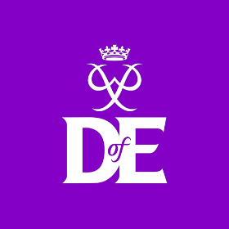
Participation in Duke of Ediburgh 2022
All of year 9 will be entered for the Duke of Edinburgh scheme this year and have the opportunity to achieve a participation certificate for completing the volunteering, physical and skills section of the award.
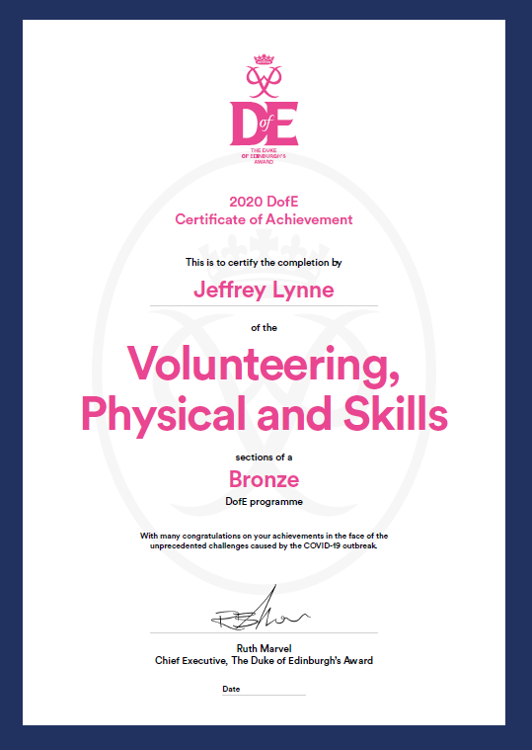
For those that make good progress towards these 3 section we have allocated 40 places for students to complete the expedition part of the award and complete their full bronze.

diary DATES 2022
DATE | ACTIVITY | YEAR
TBC 1 day | DofE Y9 Bronze in School training, map skills and camp craft. Starts 9am | Year 9
Saturday 7th May to Sunday 8th May | DofE Y9 Bronze training, leave at 8am | Year 9
Friday 11th June to Sunday 12th June | DofE Y9 Bronze qualifying, leave at 8am | Year 9

Cost
School is meeting all of the costs of the award this year, this includes registration for the award which includes the welcome back for every student, the cost of the expedition and kit hire for the 40 students that will undertake that part of the award.

Information evening & contact details
An online information evening will be held on Monday 10th January, please follow the link to join the meeting.
https://teams.microsoft.com/l/meetup-join/19%3ameeting_YTc5YWJhZTktZmE4Zi00YjMxLTg1MmMtNGI0OWY1ZmYxZWU2%40thread.v2/0?context=%7b%22Tid%22%3a%221c4d6a98-4a33-4013-9032-809f95d56277%22%2c%22Oid%22%3a%22c84f0d80-ccbc-4bb6-af14-a23f0537b5fa%22%2c%22IsBroadcastMeeting%22%3atrue%7d&btype=a&role=a
For further information or details please contact Oliver Walker.

